

TESTING

Lab 4

COMP8117-1-R-2021S

SUBMITTED TO:

Dr. Aznam Yacoub

LAB PARTNER

ARSHDEEP KAUR

110030302

SUBMITTED BY:

ANUBHA SHARMA

110037181

Version 1

28-07-2021



##### Test Cases for Sin, Cos and Tan functions

**Requirement**

1. All the functions should be able to produce result with degrees and radians.

**Testing Framework Details**

* All the functions have been coded under a utility class called TrignometricFunctions under the package assign4.math.functions.
* The Junit test runner class i.e. the main class is called TestRunner and can be found under the package assign4.junit.test
* All the test cases for the utility class have been written in JunitTrigonometricFunctionsTestClass under the package assign4.junit.test

**Test Cases:**

1. Check if sine function is working for input as degree

Junit Function: testSinedegree()

Class: JunitTrigonometricFunctionsTestClass

1. Input a degree
2. Output should be a degree.
3. Check if cos function is working for input as degree

Junit Function: testCosdegree()

Class: JunitTrigonometricFunctionsTestClass

1. Input a degree
2. Output should be a degree.
3. Check if tan function is working for input as degree

Junit Function: testTandegree()

Class: JunitTrigonometricFunctionsTestClass

1. Input a degree
2. Output should be a degree.
3. Check if sine function is working for input as radians

Junit Function: testSine()

Class: JunitTrigonometricFunctionsTestClass

1. Input a radian
2. Output should be in radians.
3. Check if cos function is working for input as radians

Junit Function: testCosine()

Class: JunitTrigonometricFunctionsTestClass

1. Input a radian
2. Output should be in radians.
3. Check if tan function is working for input as radians

Junit Function: testTan()

Class: JunitTrigonometricFunctionsTestClass

1. Input a radian
2. Output should be in radians.
3. Check if degree to radians conversion is working

Junit Function: testGetRadians *()*

Class: JunitTrigonometricFunctionsTestClass

1. Check if radians to degree conversion is working

Junit Function: testGetDegree *()*

Class: JunitTrigonometricFunctionsTestClass

**Methodology For Testing:**

1. Using @Before, initialized the TrigonometricFunction class

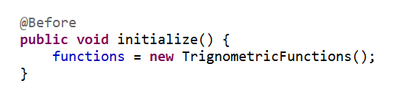

1. Created the parameters for the parameters which contains numerous positive and negative degree and radians values. These parameters will be passed to the constructor and all the test cases will be executed for each parameters.

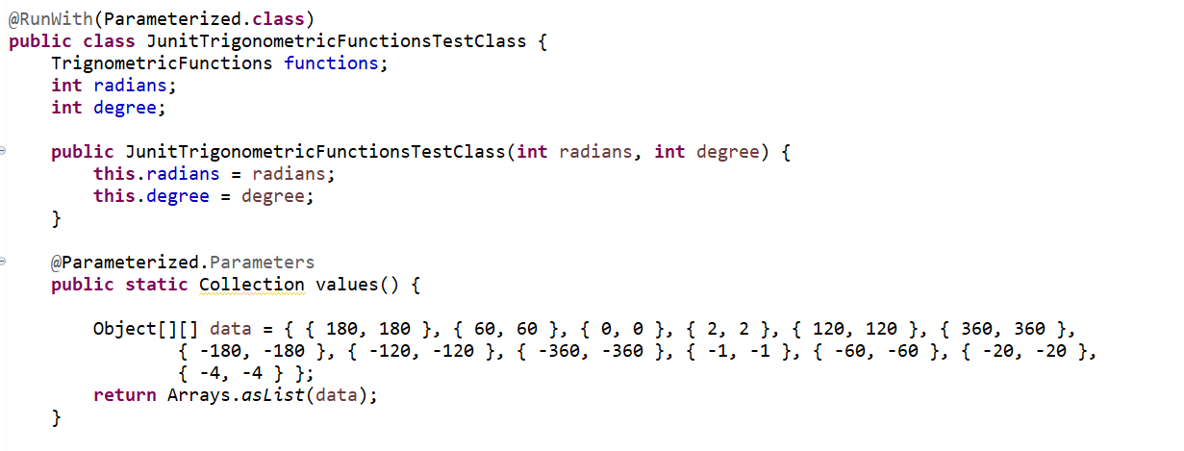

1. RESULTS: All the results for the created test class were verified against the values of the Math class.

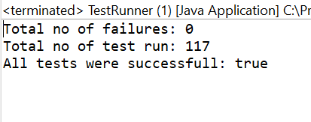

**Optional Part**

1. Downloaded Jenkins from <https://www.jenkins.io/download/>
2. Install Junit and Jenkins plugin

1. Create a pipeline in Jenkins.

1. Add github url and credentials in general tab configuration.

1. Add a branch to the Pipeline tab and name it Jenkin script path. You can write a Grovey script or use Jenkins to add code to a file.

Please find a sample Jenkins file below.

|  |
| --- |
| pipeline { |
|  | agent any |
|  |  |
|  | stages { |
|  | stage('Build') { |
|  | steps { |
|  | // git https://github.com/Anubha-31/ASE-jenkins.git' |
|  | // sh './mvnw clean compile' |
|  | bat 'mvn clean compile' |
|  | } |
|  | } |
|  | stage('Test') { |
|  | steps { |
|  | // sh './mvnw test' |
|  | bat 'mvn test' |
|  | } |
|  |  |
|  | post { |
|  | always { |
|  | junit '**/target/surefire-reports/TEST-*.xml' |
|  | } |
|  | } |
|  | } |
|  | } |
|  | } |

1. Build the Pipeline

1. Below report is generated after the pipeline is built.

